
BEEBK1013 PRINCIPLES OF ECONOMICS
FIRST SEMESTER 2026/2027 (SESSION A261)
ASSIGNMENT 1: WRITTEN REPORT

LECTURER: PROF. DR. LIM HOCK EAM
TOPIC: MINIMUM WAGE AND ITS IMPACT ON MALAYSIAN BUSINESSES
BUSINESS FOCUS: RESTAURANTS (FOOD AND BEVERAGE SERVICES)

NAME | MATRIC NUMBER
MUHAMMAD HAIKAL BIN ABDULLAH | 320144
ANIS MAISARAH BINTI MUKHRIZ IZRAF | 313365
NUREEN ATHIRAH FARAHANA BINTI SOLAHUDDIN | 319189
WAN SHAHIDAFAZLINA BINTI WAN MOHD ZIN | 319211
ALEESYA IRDINA BINTI MUHAMMAD ASHADI | 319256

1.0 Introduction

1.1 Background of the Issue
Minimum wage is the lowest basic wage that an employer must pay a worker by law. In Malaysia, the minimum wage is set under the National Wages Consultative Council Act 2011 (Act 732). The National Wages Consultative Council studies wage issues and gives its recommendation to the government (Parliament of Malaysia, 2021). By law, the rate must be reviewed at least once every two years (The Vibes, 2026b). Before deciding the rate, the council looks at the poverty line income, median wages, the Consumer Price Index (CPI), labour productivity and the unemployment rate (The Vibes, 2026a). So the rate is supposed to be fair to both workers and employers.
The minimum wage only covers the basic wage. The government has also said that employers should not use the minimum wage as the starting salary for graduates and skilled workers (Bernama, 2025a).

1.2 History of the Minimum Wage in Malaysia
Malaysia started the minimum wage in 2013. The rate was RM900 a month in Peninsular Malaysia and RM800 a month in Sabah, Sarawak and Labuan (Mahyut, 2013). After that, the rate was increased several times, as shown in Table 1 and Figure 1.
Table 1: Minimum Wage Rates in Malaysia, 2013 to 2025
Year | Peninsular Malaysia (RM a month) | Sabah, Sarawak and Labuan (RM a month) | Note
2013 | 900 | 800 | First minimum wage
2016 | 1,000 | 920 | Minimum Wages Order 2016
2019 | 1,100 | 1,100 | One rate for the whole country
2020 | 1,200 (city areas); 1,100 (other areas) | Same rule | Higher rate in 56 city and municipal council areas
2022 | 1,500 | 1,500 | Increase of RM300
2025 | 1,700 | 1,700 | Current rate
Source: Mahyut (2013), Berita Harian (2018), Parliament of Malaysia (2021), The Sun (2024a) and Bernama (2025a).
Figure 1 shows the same rates for Peninsular Malaysia as a chart, so the trend is easier to see.
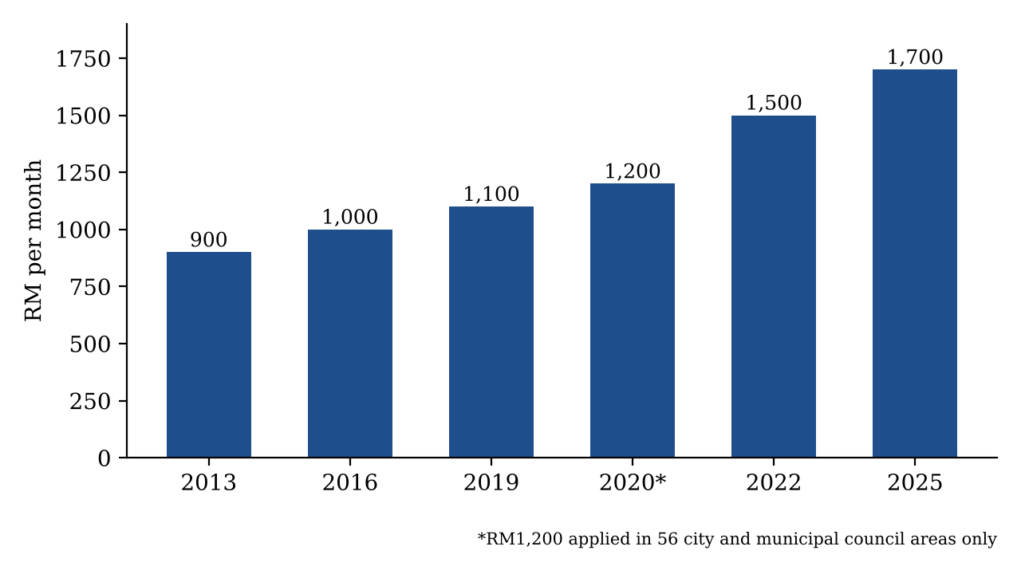
Figure 1: Minimum Wage in Peninsular Malaysia, 2013 to 2025 (RM a month)
Source: Drawn by the authors based on Table 1.
Based on Table 1, the minimum wage went up from RM900 in 2013 to RM1,700 in 2025. This is an increase of RM800, or 88.889 percent, in twelve years (own calculation). The last two increases were quite big. In 2022, it went up by RM300, from RM1,200 to RM1,500, which is 25.000 percent for workers in city areas. In 2025, it went up by RM200, from RM1,500 to RM1,700, which is 13.333 percent. The RM1,700 rate started on 1 February 2025, and about 4.37 million workers were expected to benefit. Small employers with fewer than five workers only had to follow the new rate from 1 August 2025 (Bernama, 2025a).
The government has always worried about the cost to businesses. In 2018, the government did not give any subsidy to employers because of its financial position. It also asked traders not to raise prices because of the minimum wage (Berita Harian, 2018).

1.3 The Minimum Wage Debate in 2026
The issue is still being discussed today. In August 2026, the Minister of Human Resources said the government is reviewing the RM1,700 rate again. He said the review will consider the living wage. Bank Negara Malaysia (BNM) estimated in 2018 that the living wage for a single person in Kuala Lumpur was RM2,700 (The Vibes, 2026a). At the same time, the Malaysian Trades Union Congress (MTUC) wants the minimum wage to be RM3,100. According to MTUC, some workers still earn RM1,700 even after working for ten years, because there is no proper wage structure (The Vibes, 2026b). If the rate goes up again, restaurants will be one of the first businesses to feel it.

1.4 Why We Chose Restaurants
A higher minimum wage gives workers more money, but it also means higher cost for businesses. When labour cost goes up, the owner has to decide what to do. The owner can raise prices, cut workers, cut working hours, use more machines or just accept a lower profit. The assignment asks us to choose one type of business, and we chose restaurants, which are part of the food and beverage (F&B) services sector. We have three reasons.
First, restaurants need many workers to cook, serve and clean. In 2022, the F&B services sector had 136,453 establishments and 1,079,843 workers (DOSM, 2024). Second, many restaurant workers earn close to the minimum wage. Low skilled workers were 340,465 out of 692,434 full time paid workers in the sector, or 49.169 percent (own calculation based on DOSM, 2024). Third, eating out is part of the cost of living for most Malaysians, from the mamak stall to the family restaurant. In 2025, prices for restaurant and accommodation services went up by 3.2 percent, which is more than double the overall inflation rate of 1.4 percent (DOSM, 2026b).

1.5 Objectives of the Report
The objectives of this report are:
- To explain the basic economic concepts related to the minimum wage.
- To analyse how the minimum wage affects the labour costs of restaurants.
- To analyse how the minimum wage affects restaurant prices and jobs.
- To discuss how restaurants respond and suggest some policy measures.
This report has five sections. Section 2 explains the economic concepts. Section 3 looks at the restaurant industry and its labour costs. Section 4 looks at prices and jobs. Section 5 covers how restaurants respond, our recommendations and the conclusion.

2.0 Economic Concepts

2.1 Demand and Supply of Labour
In the labour market, firms such as restaurants demand labour, and workers supply labour. The demand for labour is a derived demand. This means restaurants only hire workers because customers want to buy food, such as nasi lemak and teh tarik. When the wage goes up, owners want to hire fewer workers, so the labour demand curve slopes downward. When the wage goes up, more people want to work, so the labour supply curve slopes upward. The wage where the two curves meet is the equilibrium wage (Mahyut, 2013; Manning, 2021).

2.2 Minimum Wage as a Price Floor
A minimum wage is a price floor, which is a minimum price set by the government. Figure 2 shows what happens when the minimum wage (Wm) is set above the equilibrium wage (We). At this higher wage, more people want to work (Ls), but owners want to hire fewer workers (Ld). The difference between Ls and Ld is a surplus of labour, which means unemployment. Mahyut (2013) explained that if the minimum wage is set too high, it can reduce jobs, especially for low skilled workers. If the minimum wage is below the equilibrium wage, it has no effect because firms already pay more than that.
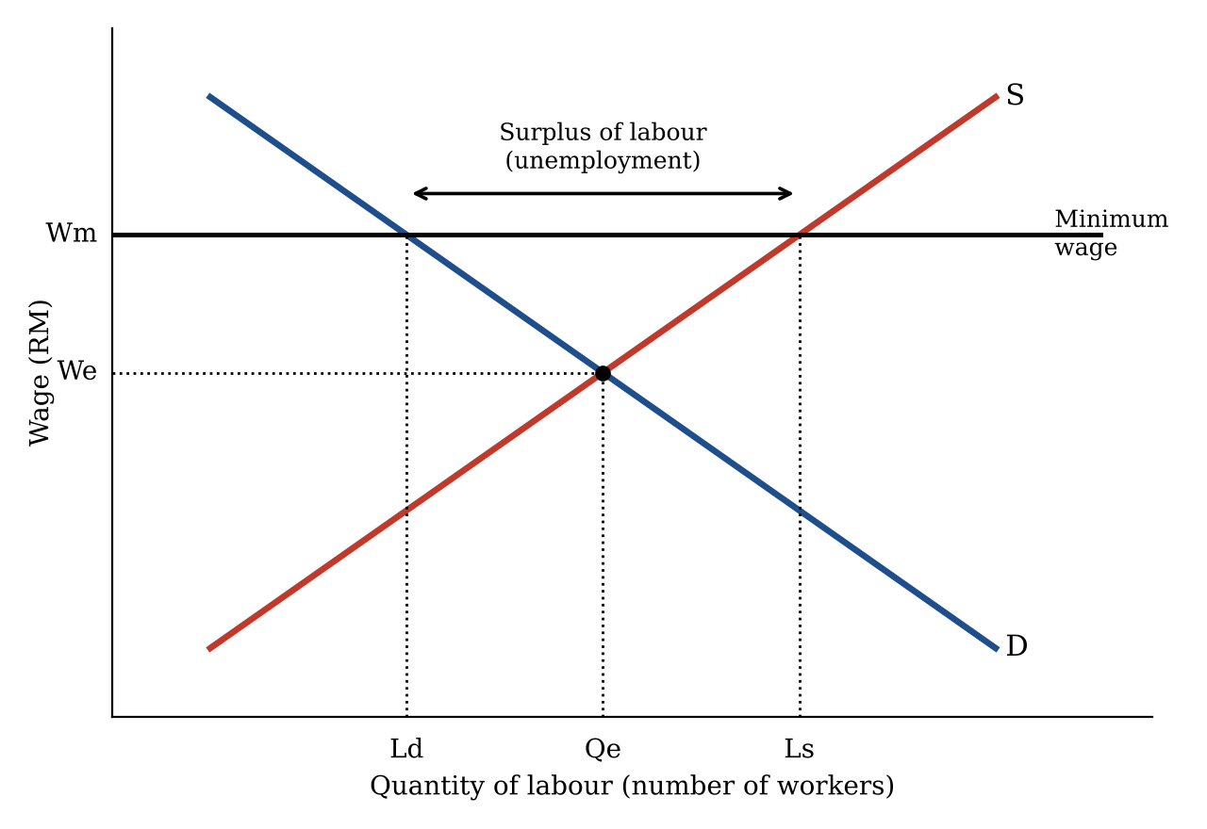
Figure 2: Minimum Wage as a Price Floor in the Labour Market
Source: Drawn by the authors based on Mahyut (2013).

2.3 Monopsony
Not all economists agree that a minimum wage will cause unemployment. In a monopsony market, there are only a few employers. These employers have the power to pay workers less than what their work is worth. In this situation, a higher minimum wage can raise wages without cutting jobs (Manning, 2021). A famous study by Card and Krueger (1994) looked at fast food restaurants in New Jersey and Pennsylvania in the United States. They found that a higher minimum wage in New Jersey did not reduce jobs in fast food restaurants. This study is useful for us because it also looked at restaurants.

2.4 Elasticity of Labour Demand
Elasticity of labour demand shows how much the number of workers changes when the wage changes. If demand is elastic, jobs fall a lot when wages go up. If demand is inelastic, jobs do not fall much. Demand is more elastic when workers are easy to replace with machines, or when customers are very sensitive to prices. Harasztosi and Lindner (2019) found that in Hungary, more jobs were lost in industries where firms could not easily pass the higher cost to customers.

2.5 Costs of Production
A restaurant has two types of costs. Fixed costs do not change with output in the short run, such as rent and equipment. Variable costs change with output, such as rice, chicken, cooking oil and wages. When the minimum wage goes up, variable cost goes up. This means the cost of making each plate of food also goes up. If the restaurant does not raise its price, its profit will be smaller (Draca et al., 2011).

2.6 Price Pass Through and Cost Push Inflation
When costs go up, a firm may raise its selling price. This is called price pass through. If many firms raise prices at the same time because of higher costs, it causes cost push inflation. In the aggregate demand and aggregate supply model, the aggregate supply curve shifts to the left and the general price level goes up. Allegretto and Reich (2018) studied restaurant menus in San Jose, California. They found that restaurants passed most of a 25 percent minimum wage increase to customers, but prices only went up by about 1.45 percent, because labour is only one part of total cost.

2.7 The Kaitz Index
The Kaitz index is the minimum wage divided by the median wage. It shows how strong the minimum wage is, or how much it "bites". If the number is high, the minimum wage is close to what a normal worker earns, so more workers and firms are affected. Mahyut (2013) mentioned that in developing countries, the minimum wage should probably be less than 40 percent of the average wage.

2.8 Summary of Expected Effects
Table 2 puts the concepts above together. It shows what economic theory says may happen to a restaurant when the minimum wage goes up. In Sections 3 and 4, we check these expectations with real Malaysian data.
Table 2: Expected Effects of a Minimum Wage Increase on Restaurants
Area | Expected effect | Related concept
Labour costs | Wages, EPF and SOCSO payments go up | Variable cost
Prices | Menu prices may go up | Price pass through, cost push inflation
Jobs | Fewer workers or fewer hours (price floor model), or little change (monopsony model) | Price floor, elasticity, monopsony
Business decisions | Use more machines, hire more locals, accept lower profit | Substitution effect
Source: Summarised by the authors from Sections 2.1 to 2.7, based on Mahyut (2013), Manning (2021) and Allegretto and Reich (2018).

3.0 The Restaurant Industry and Labour Costs

3.1 Overview of the Restaurant Industry
The F&B services sector includes food services, event catering and beverage services (DOSM, 2024). Table 3 shows the main figures from the Economic Census 2023, which uses data for 2022.
Table 3: Key Statistics of the Food and Beverage Services Sector, Malaysia, 2022
Indicator | Value
Number of establishments | 136,453
Food services establishments (share) | 107,129 (78.5%)
Value of gross output | RM99.0 billion
Value added | RM43.8 billion
Number of workers | 1,079,843
Salaries and wages paid | RM15.5 billion
Low skilled full time paid employees | 340,465
Semi skilled full time paid employees | 261,846
Skilled full time paid employees | 90,123
Source: DOSM (2024) and Bernama (2024).
Table 3 shows that the F&B sector is very big and employs more than one million people. Food services, which includes restaurants, makes up 78.5 percent of all establishments (Bernama, 2024). Selangor has the most establishments, followed by Johor and Kuala Lumpur (DOSM, 2024). The number of establishments fell from 167,490 in 2015 to 136,453 in 2022, mainly because of the Covid-19 outbreak (DOSM, 2024). This shows that small restaurants can be badly hit by shocks. The sector is still growing in 2026. In the second quarter of 2026, total salaries and wages in the F&B subsector went up by 9.9 percent compared to a year before (DOSM, 2026c).
We also calculated two simple ratios from Table 3. Salaries and wages were 15.657 percent of gross output (RM15.5 billion ÷ RM99.0 billion), and 35.388 percent of value added (RM15.5 billion ÷ RM43.8 billion) (own calculation based on DOSM, 2024). This means that for every RM100 of sales, about RM15.66 goes to paying workers.

3.2 Wages in the Restaurant Sector
Wages in accommodation and F&B are among the lowest in Malaysia. Table 4 compares the wages in this sector with the national level.
Table 4: Median and Mean Monthly Wages, Malaysian Citizens, 2024 and 2025 (RM)
Group | Median 2024 | Median 2025 | Mean 2024 | Mean 2025
All employees (Malaysia) | 2,793 | 2,940 | 3,652 | 3,803
Accommodation and F&B | 1,912 | 2,013 | 2,540 | 2,527
Elementary occupations | 1,654 | 1,758 | 2,128 | 2,184
Source: DOSM (2026a).
In 2025, the median wage in accommodation and F&B was RM2,013. This is RM927 lower than the national median of RM2,940 (DOSM, 2026a). The median wage in the sector went up by 5.282 percent from 2024 to 2025, close to the national increase of 5.3 percent (DOSM, 2026a). The new RM1,700 rate may be one reason, because it pushed up the wages of the lowest paid workers. But the mean wage in the sector fell slightly, from RM2,540 to RM2,527. We think this means the lowest paid workers got a raise, but the higher paid workers in the sector did not get as much.
Many restaurants also depend on foreign workers. The Johor Indian Muslim Entrepreneurs Association said most mamak restaurants have more than 60 percent foreign workers (Malay Mail, 2024). Owners said they are willing to pay locals up to RM2,500 a month, but not many young Malaysians want to work in restaurants (New Straits Times, 2024).

3.3 How Strong Is the Minimum Wage in Restaurants?
Using the wage data in Table 4, we calculated the Kaitz index for 2024 (RM1,500 rate) and 2025 (RM1,700 rate). The results are in Table 5 and Figure 3.
Table 5: Kaitz Index (Minimum Wage ÷ Median Wage), 2024 and 2025
Group | 2024 (RM1,500) | 2025 (RM1,700)
All employees (Malaysia) | 0.537 | 0.578
Accommodation and F&B | 0.785 | 0.845
Elementary occupations | 0.907 | 0.967
Source: Own calculation based on DOSM (2026a) and Bernama (2025a).
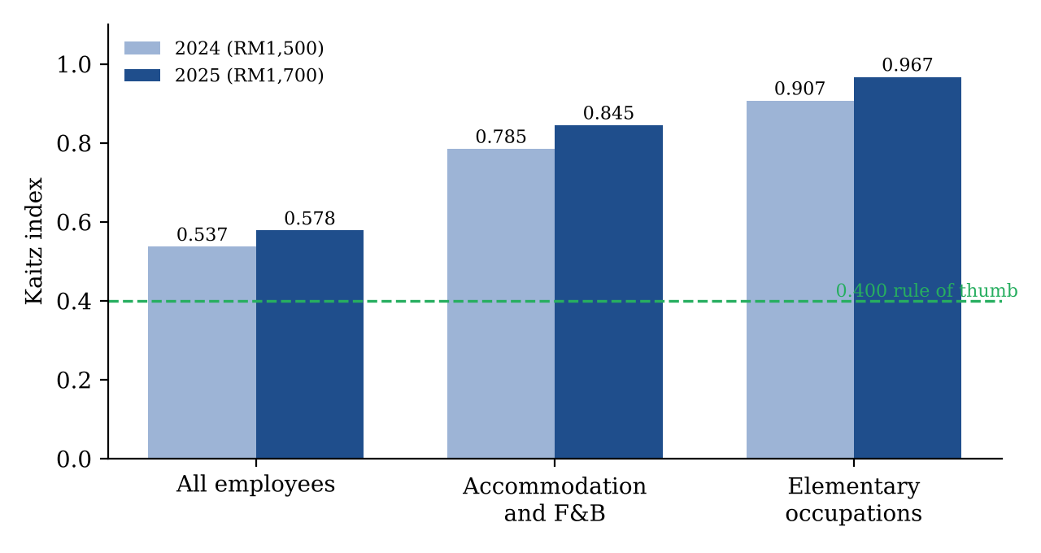
Figure 3: Kaitz Index by Group, 2024 and 2025
Source: Drawn by the authors based on Table 5.
For all employees, the Kaitz index in 2025 was 0.578. For accommodation and F&B, it was much higher at 0.845, and for elementary jobs such as kitchen helpers and cleaners, it was 0.967. This means the minimum wage is almost the same as what a normal restaurant worker earns. It is also far above the 40 percent rule of thumb (Mahyut, 2013). So when the minimum wage goes up, restaurants feel it more than most other businesses. One weakness of this calculation is that the new rate only started in 2025, so the full effect may not show yet.

3.4 Cost of Hiring One Worker
The cost of a worker is not only the basic wage. For a Malaysian worker, the employer also pays 13 percent to the Employees Provident Fund (EPF) and 1.75 percent to SOCSO (MIDA, n.d.). For foreign workers, employers had to start paying 2 percent EPF from October 2025 wages (Bernama, 2025c). We assume the employer pays 1.25 percent for the Employment Injury Scheme for foreign workers (MIDA, n.d.). Table 6 shows the monthly cost.
Table 6: Monthly Cost of One Minimum Wage Worker to the Employer (RM)
Item | Local, before | Local, after | Foreign, before | Foreign, after
Basic wage | 1,500.00 | 1,700.00 | 1,500.00 | 1,700.00
Employer EPF | 195.00 | 221.00 | 0.00 | 34.00
Employer SOCSO | 26.25 | 29.75 | 18.75 | 21.25
Total cost | 1,721.25 | 1,950.75 | 1,518.75 | 1,755.25
Increase |  | 229.50 (13.333%) |  | 236.50 (15.572%)
Source: Own calculation based on Bernama (2025a), Bernama (2025c) and MIDA (n.d.). Levy, housing and overtime are not included.
The cost of a local worker went up by RM229.50 a month, or 13.333 percent. For a foreign worker, the cost went up by RM236.50, or 15.572 percent, because of the new EPF rule. So restaurants with many foreign workers are hit twice. On top of this, owners also pay a levy of RM2,300 a year and up to RM500 a month for housing and food for each foreign worker (Malay Mail, 2024).

3.5 Example of a Small Restaurant
To make it easier to understand, we made our own example of a small restaurant. This is not a real restaurant. It has eight workers: three local workers and four foreign workers on the minimum wage, and one local cook who earns RM2,500. We assume the cook does not get a raise.
Table 7: Monthly Labour Cost of Our Example Restaurant (RM)
Worker group | Number | Total before | Total after
Local minimum wage workers | 3 | 5,163.75 | 5,852.25
Foreign minimum wage workers | 4 | 6,075.00 | 7,021.00
Local cook (RM2,500) | 1 | 2,868.75 | 2,868.75
Total | 8 | 14,107.50 | 15,742.00
Source: Own calculation based on Table 6. The cook's cost includes 13% EPF and 1.75% SOCSO.
The total labour cost goes up from RM14,107.50 to RM15,742.00 a month. That is RM1,634.50 more every month, or RM19,614 more a year, which is an increase of 11.586 percent. For a small restaurant, RM19,614 is a lot of money. It could be the same as a few months of profit. The real increase could be even higher. When the lowest paid workers get a raise, workers like the cook may also ask for more to keep the gap. This is called the spillover effect, and Senasi et al. (2021) found that Malaysian employers had to adjust their wage scales after the minimum wage started.

3.6 Effect on Total Cost
Labour is not the only cost. Restaurants also pay for raw materials, rent, electricity and gas. In Section 3.1, wages were 15.657 percent of sales. If we use this as the labour share of total cost, then an 11.586 percent rise in labour cost will raise total cost by about 15.657% × 11.586% = 1.814 percent (own calculation). So, in theory, a restaurant only needs to raise prices by about 1.814 percent to keep the same profit. But owners also faced other costs at the same time, such as higher raw material prices and the removal of diesel subsidies (The Sun, 2024b).

4.0 Impact on Prices and Jobs

4.1 What Restaurant Owners Expected
Before the RM1,700 rate started, some restaurant groups were very worried. The Malaysian Indian Restaurant Owners Association (PRIM) said food prices could go up by 20 to 30 percent (The Sun, 2024a). In Johor, around 300 mamak operators planned to raise prices by at least 5 percent (Malay Mail, 2024). In Kelantan, one restaurant owner said his buffet price would need to go up from RM35 to about RM50 per person (MalaysiaNow, 2024).
However, the Malaysian Muslim Restaurant Operators Association (Presma) did not agree. After meeting the Ministry of Domestic Trade and Cost of Living, Presma said mamak restaurants would not raise prices by 5 percent and would not use the minimum wage as an excuse (Free Malaysia Today, 2024). Presma was worried that higher prices would make customers go elsewhere and burden low income consumers (Berita Harian, 2024). This is related to the price elasticity of demand. If customers are sensitive to price, a restaurant that raises its price may lose customers.

4.2 What Actually Happened to Prices
Table 8 and Figure 4 show the latest price data related to restaurants.
Table 8: Price Changes Related to Restaurants in Malaysia (Year on Year)
Indicator | Period | Change | Source
CPI: Restaurant and accommodation services | 2025 | 3.2% | DOSM (2026b)
CPI: Overall inflation | 2025 | 1.4% | DOSM (2026b)
CPI: Food away from home | August 2025 | 4.3% | Bernama (2025b)
CPI: Food at home | August 2025 | −0.1% | Bernama (2025b)
CPI: Restaurant and accommodation services | August 2026 | 2.1% | Malay Mail (2026)
Producer price: Restaurant and mobile food services | Q2 2026 | 5.8% | Business Today (2026)
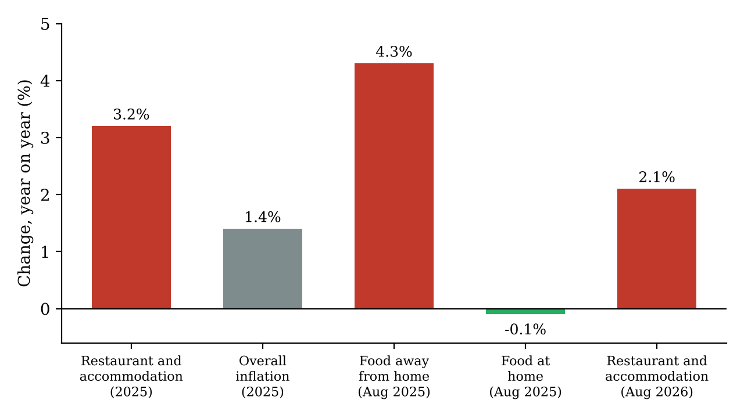
Figure 4: Selected Price Changes Related to Restaurants in Malaysia
Source: Drawn by the authors based on DOSM (2026b), Bernama (2025b) and Malay Mail (2026).
From Table 8 and Figure 4, we found four things. First, restaurant prices went up faster than general prices. In 2025, restaurant and accommodation prices rose by 3.2 percent, but overall inflation was only 1.4 percent (DOSM, 2026b). This supports the idea of cost push inflation in the restaurant sector.
Second, eating out became more expensive, but cooking at home did not. In August 2025, food away from home went up by 4.3 percent, while food at home went down by 0.1 percent (Bernama, 2025b). Since raw food prices did not go up, the extra cost of eating out probably came from other things like labour, rent and utilities. We think this shows the minimum wage increase played a part.
Third, the price increase was much smaller than the 20 to 30 percent warning by PRIM. Competition, government monitoring and price sensitive customers stopped restaurants from raising prices too much.
Fourth, prices for customers are slowing down, but costs for owners are still going up. By August 2026, restaurant and accommodation inflation had dropped to 2.1 percent (Malay Mail, 2026). But the producer price for restaurant services still rose by 5.8 percent in the second quarter of 2026 (Business Today, 2026). This means owners still face rising costs, so menu prices may go up again later.
The actual increase of 3.2 percent is also higher than our estimate of 1.814 percent in Section 3.6. So the minimum wage can only explain part of the price increase. Other costs such as rent, raw materials and diesel also pushed prices up (The Sun, 2024b). Harasztosi and Lindner (2019) found that in Hungary, about 75 percent of the minimum wage cost was paid by consumers through higher prices, and 25 percent by owners through lower profits. In Malaysia, it looks like consumers also paid a big part, but owners had to absorb some of it too.

4.3 What Happened to Jobs
Many people worry that a higher minimum wage will cause job losses. The Kelantan Restaurant Owners Association said owners would have no choice but to cut staff (MalaysiaNow, 2024). Table 9 shows what happened after the RM1,700 rate started.
Table 9: Selected Labour Market Indicators, Malaysia
Indicator | Earlier | Latest | Source
Unemployment rate | 3.0% (June 2026) | 3.0% (July 2026) | Bernama (2026)
Employed persons | 16.83 million (June 2026) | 16.85 million (July 2026) | Bernama (2026)
Youth unemployment rate (15 to 24 years) | 10.2% (June 2026) | 10.2% (July 2026) | Bernama (2026)
Full time paid employees, citizens | 10.24 million (2024) | 10.38 million (2025) | DOSM (2026a)
Part time paid employees, citizens | 591,100 (2024) | 737,900 (2025) | DOSM (2026a)
Table 9 does not show big job losses. The unemployment rate stayed at 3.0 percent in July 2026, and the number of employed persons kept going up (Bernama, 2026). DOSM also said that accommodation and F&B services was one of the activities that added jobs in July 2026 (Bernama, 2026). This is similar to what Card and Krueger (1994) found. In Malaysia, Kek and Lai (2023) found that the minimum wage had a positive effect on the employment of low skilled workers, although the effect was not significant in some of their tests.
But there is one change that is easy to miss. Part time paid employees who are citizens went up from 591,100 in 2024 to 737,900 in 2025, an increase of 24.835 percent. Full time paid employees only went up by 1.367 percent (own calculation based on DOSM, 2026a). Figure 5 shows the difference.
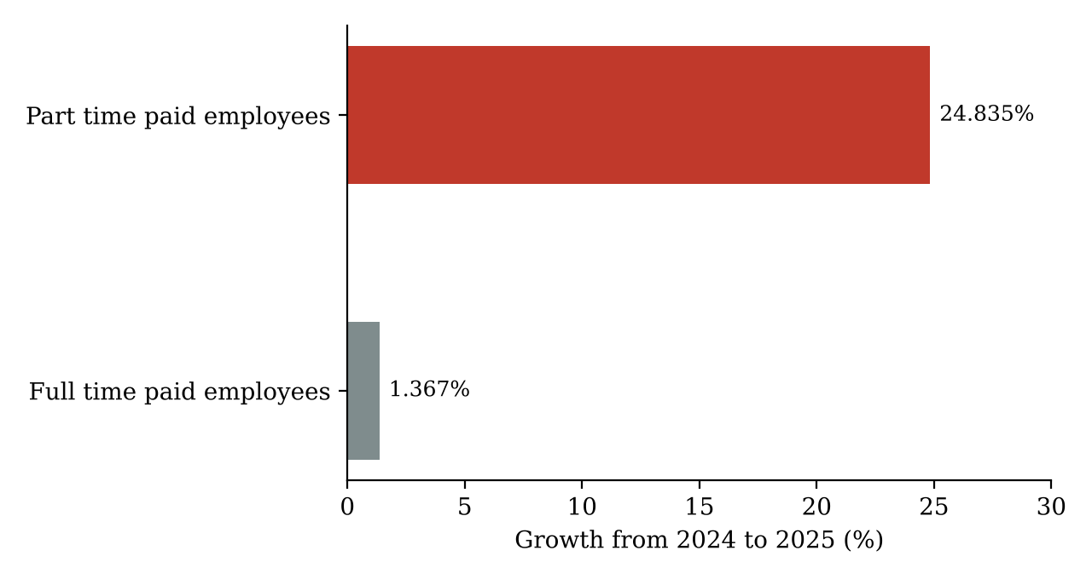
Figure 5: Growth of Paid Employees (Citizens), 2024 to 2025
Source: Own calculation based on DOSM (2026a).
We cannot say for sure that this is because of the minimum wage, because the data covers all sectors. There can be other reasons, such as students working part time. But it is possible that some restaurants now hire more part time workers for lunch and dinner time, instead of paying full time workers for the whole day. In other words, owners may be cutting working hours instead of cutting jobs.

4.4 Why Were Job Losses Small?
We think there are four reasons. First, people kept eating out. Revenue in the F&B and related segments grew in 2026 because of festive spending and school holidays (The Star, 2026), and when demand for food is strong, demand for workers is also strong. Second, restaurants passed part of the cost to customers, as shown in Section 4.2. Third, restaurant workers are already hard to find, even at RM2,500 a month (New Straits Times, 2024), so owners do not want to lose them. Fourth, the 13.333 percent increase in 2025 was smaller than the 25.000 percent increase in 2022.
Still, we need to be careful. National data cannot show what happens to very small restaurants, especially in poorer states. Youth unemployment is also still high at 10.2 percent (Bernama, 2026). If the minimum wage jumps to RM3,100 as MTUC proposed (The Vibes, 2026b), the risk of job losses for young and low skilled workers will be much higher.

5.0 Business Responses, Recommendations and Conclusion

5.1 How Restaurants Respond
Restaurant owners usually use more than one strategy. First, some owners may hire more local workers. Foreign workers now also get RM1,700, plus 2 percent EPF, a levy and housing (Bernama, 2025c; Malay Mail, 2024), so they are no longer much cheaper than locals. The Johor Indian Muslim Entrepreneurs Association said some owners may hire more locals because of this (New Straits Times, 2024). This also matches one of the original aims of the minimum wage, which is to reduce dependence on cheap foreign labour (Mahyut, 2013).
Second, some owners use technology such as QR code ordering, self service kiosks and digital payment. This is called the substitution effect, where machines replace workers when labour becomes more expensive. Lordan and Neumark (2018) found that minimum wage increases reduced the share of low skilled jobs that are easy to automate. When the minimum wage was first introduced, about 40 percent of firms in a BNM survey planned to increase automation (Mahyut, 2013). But technology is expensive, so it suits big chain restaurants more than small mamak stalls.
Third, owners may try to improve productivity, for example by training workers to do more than one job or making the menu simpler. Senasi et al. (2021) found that the minimum wage affected labour productivity in Malaysia, and that training was the one benefit that employers cut. Fourth, some owners have to accept lower profit. Presma said its members were absorbing higher diesel, rent and raw material costs (The Sun, 2024b). Draca et al. (2011) found that the minimum wage in the United Kingdom reduced the profits of affected firms. For very small restaurants, this can lead to closure.
Lastly, owners can get help from the government. Under the Progressive Wage Policy, eligible companies can get up to RM200 a month for entry level workers and up to RM300 a month for other workers when they raise wages based on skills. So far, 4,025 employers have claimed incentives and 51,363 workers have benefited (The Vibes, 2026a).
Table 10 sums up these strategies, with the good and bad side of each one.
Table 10: How Restaurants May Respond to a Higher Minimum Wage
Strategy | Good side | Bad side | Suitable for
Raise menu prices | Keeps profit | May lose customers | Restaurants with loyal customers
Hire more part time workers | Workers only at busy hours | Less stable workers | Restaurants with clear peak hours
Hire more local workers | No levy or housing cost | Locals are hard to find | Most restaurants
Use technology | Need fewer workers later | High starting cost | Big chain restaurants
Train workers | Better service, staff stay longer | Takes time and money | Medium and big restaurants
Accept lower profit | Keeps customers and workers | Small shops may close | Restaurants with good profit
Apply for Progressive Wage incentives | Government helps pay wages | Only for Malaysian workers, needs paperwork | Registered companies
Source: Summarised by the authors from the sources in Section 5.1 and Section 4.3.

5.2 Who Gains and Who Loses?
The minimum wage does not affect everyone in the same way. Low paid restaurant workers gain the most. Their wages went up, with the median wage in the sector rising by 5.282 percent from 2024 to 2025, and there is no clear sign of big job losses (DOSM, 2026a; Bernama, 2026). However, some workers may now get fewer hours or only part time work.
Consumers pay part of the cost through higher restaurant prices, which rose by 3.2 percent in 2025 (DOSM, 2026b). This hits people who eat out often, such as students and workers in the city. But many consumers are also workers who got a raise. So the effect on their real income depends on whether their wages go up faster than prices.
Restaurant owners face the most pressure, especially small restaurants with many foreign workers. In our example, labour cost went up by 11.586 percent. Big restaurants can use technology or change prices more easily, but small restaurants in low income areas have less room to move.
For the whole economy, there is a good side. Low income households usually spend most of their extra income, so higher wages can increase spending in the economy (Mahyut, 2013). A higher minimum wage can also push businesses to improve productivity and depend less on cheap foreign labour, which supports Malaysia's plan to become a high income country (The Vibes, 2026a).

5.3 A Warning About a Very Big Increase
Table 11 shows what the Kaitz index would be if the minimum wage went up to the levels being discussed in 2026.
Table 11: Kaitz Index Under Different Minimum Wage Levels (Based on 2025 Median Wages)
Minimum wage level | All employees (median RM2,940) | Accommodation and F&B (median RM2,013)
RM1,700 (current rate) | 0.578 | 0.845
RM2,700 (BNM living wage estimate) | 0.918 | 1.341
RM3,100 (MTUC proposal) | 1.054 | 1.540
Source: Own calculation based on DOSM (2026a), The Vibes (2026a) and The Vibes (2026b).
At RM3,100, the minimum wage would be 1.540 times the median wage in accommodation and F&B. This means about half of the workers in the sector would need a pay rise of more than 50 percent. Based on the price floor model in Section 2.2, and the finding that more jobs are lost when firms cannot pass on costs (Harasztosi & Lindner, 2019), we think such a big jump is too risky for restaurants, even though the living wage is a good goal.

5.4 Recommendations
Based on our findings, we suggest four things to the government.
- Raise the minimum wage step by step, with a clear timetable. In 2018, the government itself said a gradual increase can help small employers survive (Malaysiakini, 2018). The downside is that workers need to wait longer for a living wage.
- Give micro businesses more time to adjust, like the six extra months given in 2025 (Bernama, 2025a). However, workers in small businesses will get the new rate later.
- Make the Progressive Wage Policy easier for small restaurants to apply for (The Vibes, 2026a). This will cost the government more money.
- Help small restaurants use technology through grants or soft loans for digital ordering and payment systems. This can raise productivity, but some cashier jobs may be lost in the long run (Lordan & Neumark, 2018).
We also think the government should keep monitoring restaurant prices, as it did with Presma in 2024 (Free Malaysia Today, 2024), but it should not use strict price controls, because restaurants still need to cover their real costs.

5.5 Conclusion
This report looked at how the increase in the minimum wage from RM1,500 to RM1,700 affected restaurants in Malaysia. We found that the minimum wage bites harder in restaurants than in most other sectors, with a Kaitz index of 0.845 compared to 0.578 for all employees. The cost of one minimum wage worker went up by 13.333 percent for locals and 15.572 percent for foreign workers, and labour cost in our example restaurant went up by 11.586 percent. Restaurant prices rose faster than general prices in 2025, but much less than what some owners had warned. So far, there are no big job losses, but the fast growth in part time work shows that some owners may be cutting hours instead.
Overall, we think the RM1,700 minimum wage has been manageable for most restaurants, mainly because people kept eating out and owners could pass some of the cost to customers. The people who carried most of the burden were consumers and small restaurants with low profit. A very big jump, such as RM3,100, could cause serious problems. We believe the best way forward is to raise the minimum wage step by step and give small restaurants more help, so that workers get better pay and restaurants can still survive.
This report also has some limitations. Our restaurant example is not based on a real restaurant, some census data is from 2022, and it is hard to separate the effect of the minimum wage from other cost increases at the same time. A future study could interview restaurant owners or collect menu prices directly.

References
Allegretto, S., & Reich, M. (2018). Are local minimum wages absorbed by price increases? Estimates from internet-based restaurant menus. ILR Review, 71(1), 35–63. https://doi.org/10.1177/0019793917713735
Bernama. (2024, August 5). 136,453 F&B services premises with RM99 bln gross output value operating in 2022: DoSM. https://www.bernama.com/en/news.php?id=2325567
Bernama. (2025a, February 1). New RM1,700 minimum wage takes effect today. https://www.bernama.com/en/news.php?id=2388340
Bernama. (2025b, September 23). Malaysia's inflation rises 1.3 pct in August: DOSM. https://bernama.com/lite/news.php?id=2470472
Bernama. (2025c, June 25). Mandatory EPF contributions for foreign workers to begin in October. https://www.bernama.com/en/news.php?id=2438262
Bernama. (2026, September 11). Unemployment rate unchanged at 3.0 pct in July: DOSM. https://bernama.com/en/general/news.php?id=2605959
Berita Harian. (2018, September). Gaji minimum seragam RM1,050 berkuat kuasa tahun depan. https://www.bharian.com.my/amp/berita/nasional/2018/09/470278/bhplus
Berita Harian. (2024, November). PRESMA harap cadangan restoran mamak di Johor naik harga makanan bermula 5 peratus tahun depan diteliti semula. https://www.bharian.com.my/amp/berita/nasional/2024/11/1322784/bhplus
Business Today. (2026, August 6). Services producer index up 2.9% in Q2 2026, driven by surge in air travel, dining out: DOSM report. https://www.businesstoday.com.my/2026/08/06/services-producer-index-up-2-9-in-q2-2026-driven-by-surge-in-air-travel-dining-out-dosm-report/
Card, D., & Krueger, A. B. (1994). Minimum wages and employment: A case study of the fast-food industry in New Jersey and Pennsylvania. The American Economic Review, 84(4), 772–793. https://www.jstor.org/stable/2118030
Department of Statistics Malaysia. (2024, August 5). Economic Census 2023: Food and beverage services sector. https://www.dosm.gov.my/portal-main/release-content/economic-census-2023-food-and-beverage-services-sector
Department of Statistics Malaysia. (2026a). Salaries & wages survey report, Malaysia, 2025. https://storage.dosm.gov.my/labour/salaries_wages_2025.pdf
Department of Statistics Malaysia. (2026b, April 29). Analysis of annual consumer price index, Malaysia, 2025. https://www.dosm.gov.my/portal-main/release-content/analysis-of-annual-consumer-price-index-malaysia-2025
Department of Statistics Malaysia. (2026c, August 12). Quarterly services statistics, second quarter 2026. https://www.dosm.gov.my/portal-main/release-content/quarterly-services-statistics-q22026
Draca, M., Machin, S., & Van Reenen, J. (2011). Minimum wages and firm profitability. American Economic Journal: Applied Economics, 3(1), 129–151. https://doi.org/10.1257/app.3.1.129
Free Malaysia Today. (2024, November 14). No 5% price hike at mamak restaurants, says Presma. https://www.freemalaysiatoday.com/category/nation/2024/11/14/no-5-price-hike-at-mamak-restaurants-says-presma
Harasztosi, P., & Lindner, A. (2019). Who pays for the minimum wage? American Economic Review, 109(8), 2693–2727. https://doi.org/10.1257/aer.20171445
Kek, J. W., & Lai, W. S. (2023). Minimum wage and employment of Malaysian low-skilled workers. Malaysian Journal of Economic Studies, 60(2), 255–273. https://doi.org/10.22452/MJES.vol60no2.6
Lordan, G., & Neumark, D. (2018). People versus machines: The impact of minimum wages on automatable jobs. Labour Economics, 52, 40–53. https://doi.org/10.1016/j.labeco.2018.03.006
Mahyut, S. M. (2013). Minimum wage in Malaysia: The challenge on the implementation of the law. International Journal of Business, Economics and Law, 3(3), 30–37. https://www.ijbel.com/wp-content/uploads/2014/01/KLL3326-SITI-MARSHITA-MINIMUM-WAGE-IN-MALAYSIA-THE-CHALLENGE-ON-THE-IMPLEMENTATION-OF-THE-LAW.pdf
Malay Mail. (2024, November 12). Citing new minimum wage of RM1,700, Johor mamak eateries want to hike price by at least 5pc from 2025. https://www.malaymail.com/news/malaysia/2024/11/12/citing-new-minimum-wage-of-rm1700-johor-mamak-eateries-wants-to-hike-price-by-at-least-5pc-from-2025/156565
Malay Mail. (2026, September 18). DOSM: Malaysia's August inflation edges up to 1.9pc on higher transport, services costs. https://www.malaymail.com/news/money/2026/09/18/dosm-malaysias-august-inflation-edges-up-to-19pc-on-higher-transport-services-costs/235641
Malaysiakini. (2018, September). Gaji minimum seragam RM1,050 berkuat kuasa 1 Jan 2019. https://www.malaysiakini.com/news/441849
MalaysiaNow. (2024, October 23). Price revision and staff cuts: Restaurant group warns of flipside of raising minimum wage. https://malaysianow.com/news/2024/10/23/price-revision-and-staff-cuts-restaurant-group-warns-of-flipside-of-raising-minimum-wage
Malaysian Investment Development Authority. (n.d.). Statutory contributions. Retrieved October 3, 2026, from https://www.mida.gov.my/setting-up-business/statutory-contributions/
Manning, A. (2021). The elusive employment effect of the minimum wage. Journal of Economic Perspectives, 35(1), 3–26. https://doi.org/10.1257/jep.35.1.3
New Straits Times. (2024, November). 300 mamak restaurant operators in Johor plan to raise prices by 5pct next year. https://nst.com.my/news/nation/2024/11/1133105/300-mamak-restaurant-operators-johor-plan-raise-prices-5pct-next-year
Parliament of Malaysia. (2021, December 16). Pertanyaan bukan lisan No. 42: Gaji minimum [Written parliamentary reply]. https://pardocs.sinarproject.org/documents/2021-september-december-parliamentary-session/written-replies-bukan-lisan/20211216-par14p4m1-soalan-bukanlisan-42.pdf
Senasi, V., Khalil Halim, S., & Parasuraman, B. (2021). Minimum wage policy: Is there any impact on low skilled workers in electrical and electronics companies in Malaysia? International Journal of Business and Society, 22(1), 422–430. https://doi.org/10.33736/ijbs.3186.2021
The Star. (2026, August 12). Services sector revenue up 11.2% to RM714.7bil in 2Q 2026: DOSM. https://www.thestar.com.my/business/business-news/2026/08/12/services-sector-revenue-up-112-to-rm7147bil-in-2q-2026---dosm
The Sun. (2024a). Johor mamak eateries expected to raise prices by 5%. https://thesun.my/news/malaysia-news/johor-mamak-eateries-expected-to-raise-prices-by-5-hh13274267/
The Sun. (2024b, November 13). Price hike proposal by Johor Indian-Muslim group opposed. https://thesun.my/news/malaysia-news/price-hike-proposal-by-johor-indian-muslim-group-opposed-hi13284113/
The Vibes. (2026a, August 18). Govt reviews RM1,700 minimum wage, with possible increase under new wage formula. https://www.thevibes.com/index.php/articles/news/126291/govt-reviews-rm1700-minimum-wage-with-possible-increase-under-new-wage-formula
The Vibes. (2026b, August 24). RM3,100 minimum wage proposal puts Malaysian workers' pay at a crossroads. https://www.thevibes.com/articles/news/126507/rm3100-minimum-wage-proposal-puts-malaysian-workers-pay-at-a-crossroads

